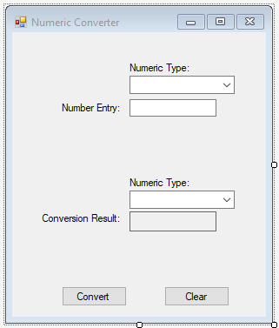After loading up the Number converter program, there will be a textbox that is labeled “Number Entry” and a combo box above it labeled “Numeric Type” above it. There will also be another “Numeric Type” combo box and then an output label that says, “Conversion Result”. You will want to enter the number you want converted into the Number entry textbox. Now depending on what type of number it is, you will have to select a type in the first Numeric type combo box. Then, you want to choose which type you want the number to be converted into by using the second Numeric type combo box. Lastly, when all the values you want are entered, you want to hit the Convert button and your value will be converted into the desired type. And when you are all done, you can hit the clear button to get rid of all the text, so you can have a fresh form. There are 4 numeric types you can choose from on my form. They are Binary, Hexadecimal, Roman Numerals, and Arabic. You are able to convert between them freely.